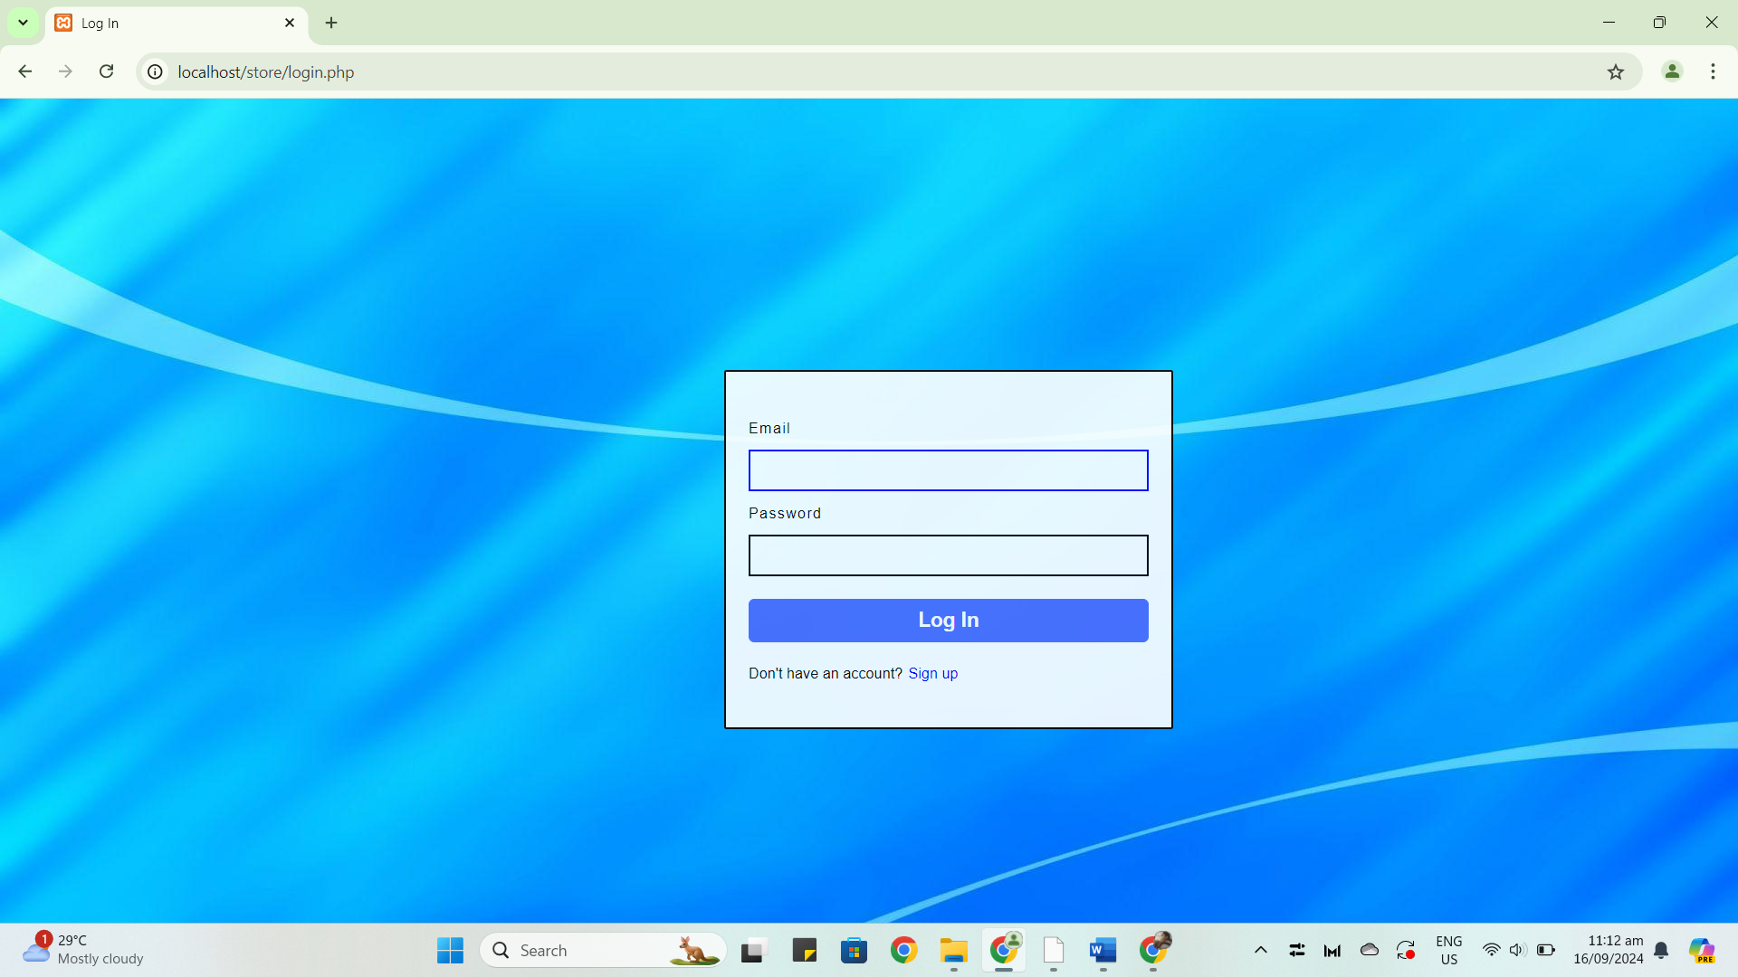

**Log in process**

* Before accessing the homepage of the e-commerce, the user needs to access the log-in page first.
* The user should enter the corresponding credentials to the account, if the user doesn’t have an account, proceed to the registration page. The button is seen in the lower corner of the “Log In” button, it is indicated as “Sign Up.”

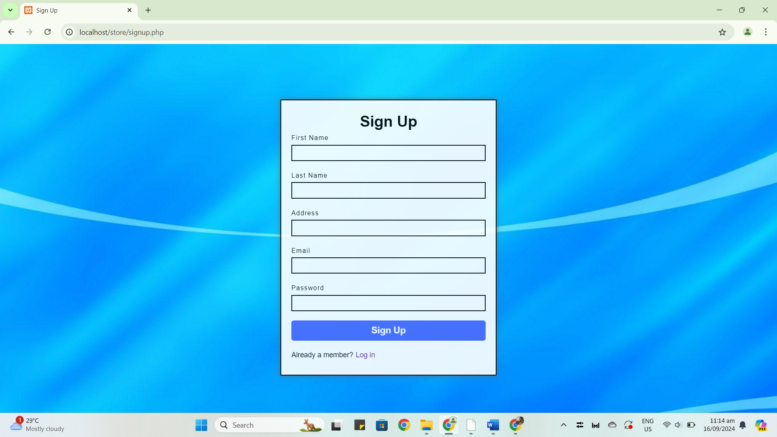

**Registration Process**

* If the user doesn't have an account, they need to sign up first.
* The user need to fill up the field that are needed to fill up, such as the user's first name, last name, address, email, and password.
* After signing up, the user will be redirected to the "Log In" page to log in to their account.

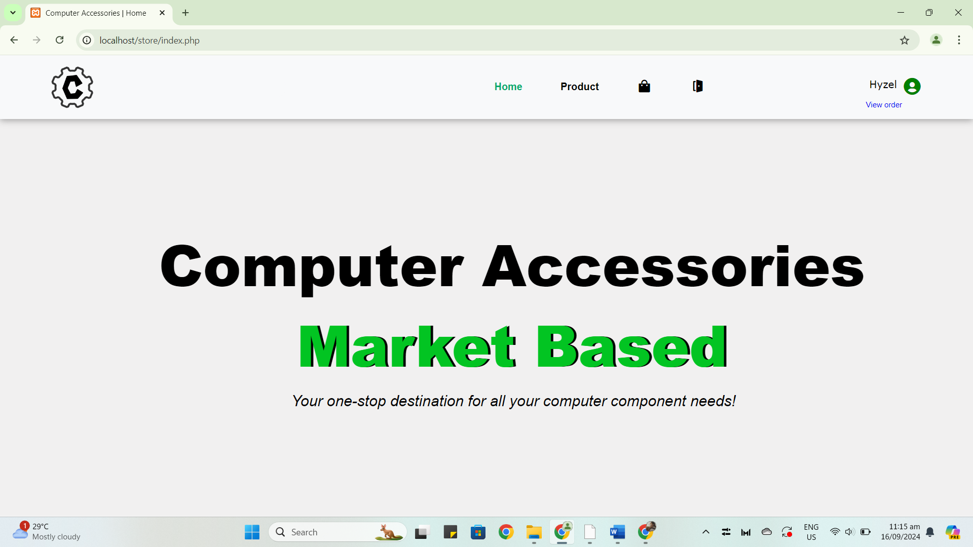

**User Homepage**

* This is the homepage after the user will successfully log in.

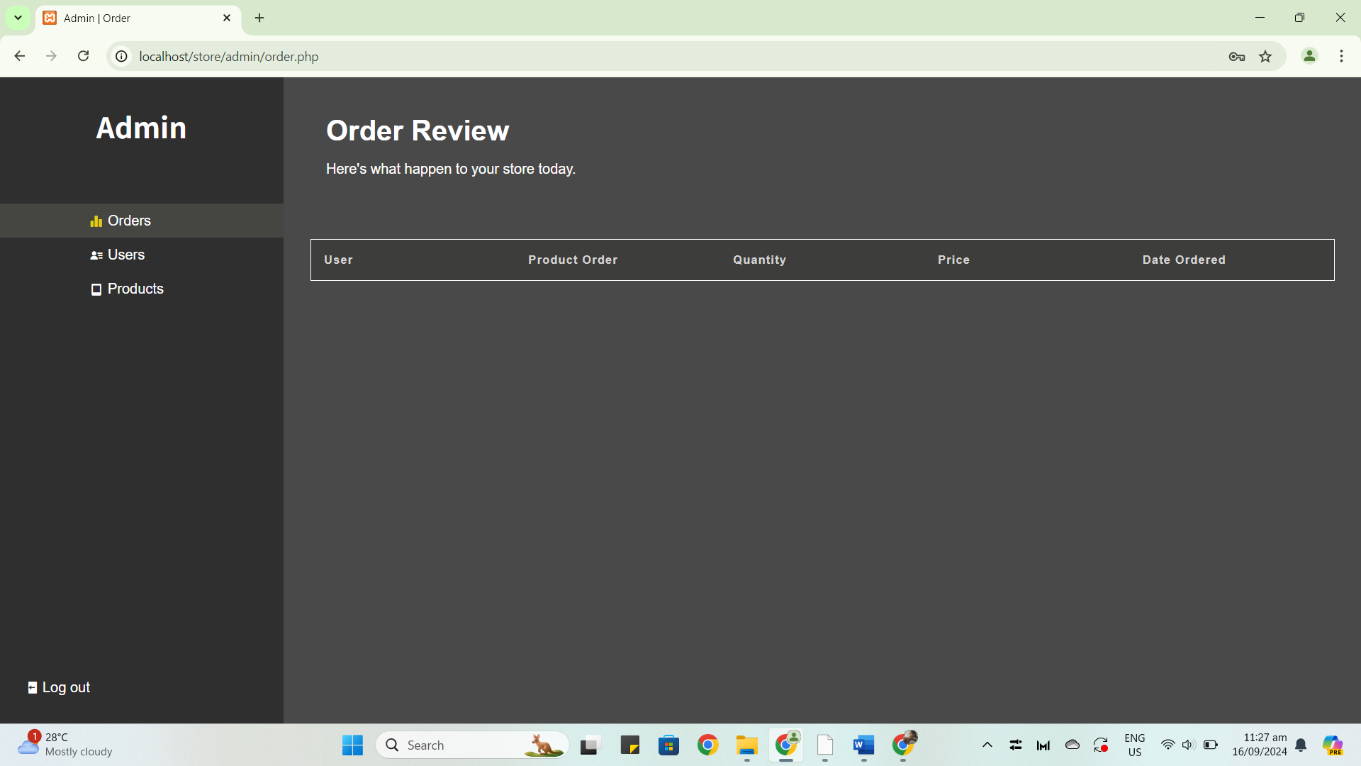

**Admin Homepage**

* This is also the homepage after the admin will successfully log in.

**Tips for Users:**

* You should not forget your password.
* Ensure that your email is unique and accessible.

